**Wiki page for Lab Asmt 9**

1. Create a Private REST service that is Mashup of at least two public REST services.
2. Use this private web service in your web/mobile/hybrid application
3. Try to use a different web service and create some good use case
4. Application should have good UI/UX.

**Please find the screenshots below:**

**Log-In Screen:**

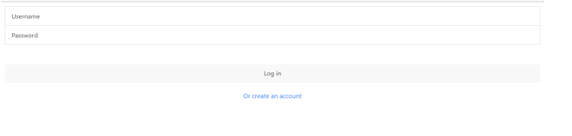

**Home Screen:**



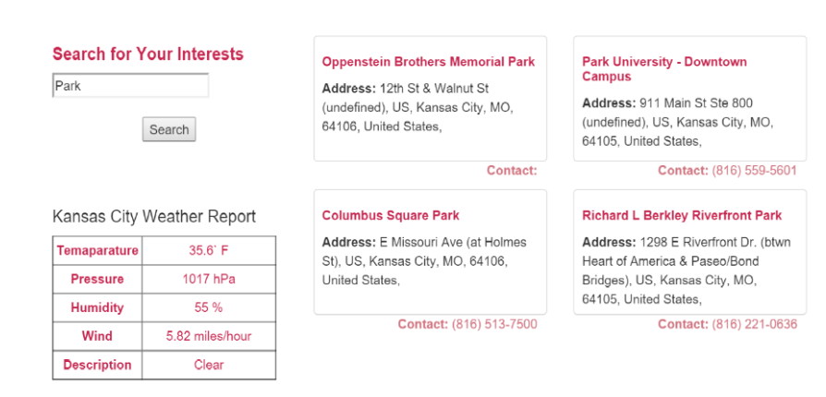

**Code:**

